RESTORATIVE JUSTICE RESEARCH PROJECT REPORT

Background

This research was undertaken for the Centre for Restorative Justice (CRJ), a division of Offenders Aid & Rehabilitation Services of SA (OARS SA) as a part of a Field Placement for postgraduate studies in the Masters of Mediation and Conflict Resolution at the University of South Australia. The aim of the research is to ensure best practice is implemented in school communities.

The Statement of Purpose -

Aim

To ascertain the effectiveness of restorative practices in helping the participating schools build healthier school communities.

Objectives

- To increase and develop capacity and professionalism in The Centre for Restorative Justice

- To increase the effectiveness of the evaluation of outcomes of restorative practices in schools

- To raise awareness and broaden understanding of the work of The Centre for Restorative Justice in others.

CRJ VISION

The development of community and justice systems that deal with conflict and consequences of offending in a restorative manner

CRJ MISSION

To reduce conflict within the community and to work towards repairing harm by enabling the development of restorative approaches in justice and other settings:

- By providing the opportunity for people who have been affected by conflict to be a part of the healing process

- By helping people to heal themselves as a means of preventing the occurrence, onset and re-occurrence of conflict

CRJ definition of Restorative Justice (RJ)

RJ is a range of process’s that advocate that the people most effective at finding a solution to a problem are the people who are most directly impacted by the problem.

Opportunities are created for those involved in conflict to work together to understand, clarify, resolve the incident and work together towards repairing the harm caused.

Method

A questionnaire (see Appendix 1) was delivered via a face-to-face interview with the designated staff member from the eleven participating schools. This method was seen to offer a chance for incidental comments to be offered and in recognition that schools have their own culture and might use individualised terms for similar practices across sites. All responses were recorded by the interviewer, including the Case Studies (see Appendix 2).

The participating schools were chosen by the CRJ on the basis of their having received training and support through them, and participation in the research was voluntary.

A sample questionnaire (Appendix 1) was sent to the school prior to the interview so that respondents had knowledge of the questions and an opportunity to gather data if relevant.

The questionnaire was divided into four sections with an overall focus on ‘before’ and ‘after’ the introduction of restorative approaches into the school’s management of behaviour issues The majority of questions asked respondents to choose a rating from 1 to 5, with 1 being the lowest and 5 being the highest.

Findings

Section One – School Profile and Implementation of Restorative Practices

Q1. School description
Q2. Approximate population

A range of schools from the Government, Independent and Catholic sectors were represented by the eleven schools. Five schools fell into the category of Government co-educational primary school, the most represented category. One Government co-educational high school and one Independent co-educational high school were represented along with three R-12 schools, one being Government co-educational, one Independent co-educational (their junior school was the focus of this research) and the other a single sex Independent school. Also represented was one Independent co-educational primary school.

The school populations ranged from a small Government co-educational R-12 school of 120 students to a large Government co-educational high school of 1,000 students.

Given that the overall findings of the research suggest the use of restorative approaches to be highly successful in building positive relationships and managing student behaviour the above indicates that restorative approaches work (and can be adapted) for a range of different types and sizes of schools.

Q3. Current position of the respondent

Q4. Your knowledge of restorative practices at the school

Q5. Your involvement in restorative practices at the school

Q6. How many years has the school been using restorative practices

The respondents from each school held a leadership position with five being School Counsellors (one of these Acting in the position). Five of the respondents were in senior management positions, two as Principal, one as Deputy Principal, one Dean of Students and one as Head of Junior School. One respondent was the Learning Support Co-ordinator.

All respondents, except one, who was acting in her capacity, rated their knowledge of restorative practices at the school as high or very high.

All respondents were either highly or very highly involved in the use of restorative practices. This high knowledge and involvement of respondents indicates a high degree of credibility of the responses.

The number of years restorative practices had been used varied with the highest being one school at 6 and the lowest two at 1, although these two schools qualified this response with the comment that they had been involved ‘informally’ in the use of restorative practices for some years prior to this. One school which began implementation 2 years ago consider that they are still in a transition phase. Taken together the participating schools had a combined total of 34 years experience in using restorative practices.

Q7. The school’s use of restorative practices as an integrated whole school approach to behaviour management
Q8. Percentage of staff using restorative approaches
Q9. Number of hours of professional development on restorative practices staff have undertaken in the past 12 months
Q10. Nature of professional development

The majority of schools considered their use of restorative practices to be a whole school approach, and indeed aimed for this as best practice. One Government school noted that this fluctuated as a result of changes in staffing and the availability of resources for training. Such changes in staffing meant that the ‘language’ of the practices falls out of use as the number of staff who have undergone formal training drops.

The use of restorative practices by staff members was reported to be high. Two schools reported 100% of staff using these approaches and a further six reported 80% involvement. The school reporting 40% involvement highlighted the change in personnel as a reason for lower than average involvement. The school with the lowest involvement of staff at 20% were in their first year of the formal adoption of restorative practices and currently it was mostly management utilising the practices, rather than classroom teachers. This same school had rated their approach very low in terms of an integrated whole school approach and considered restorative approaches to be a complementary foundation for a new ‘behaviour management platform’ they had introduced recently.

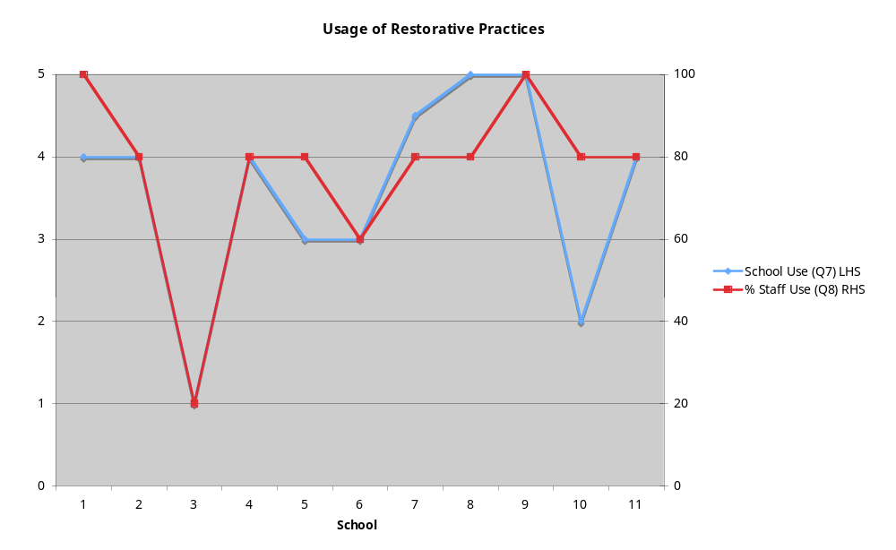

Six schools undertook more than ten hours of professional development in restorative practices in the last 12 months, indicating a strong commitment to RJ practices. Of the schools which cited only 2-4 hours of training, one stated change of personnel as the main factor, another, that due to full staff training only two years prior, only new staff members are currently trained. Two schools noted that they have had separate dedicated training for staff in leadership positions.

Many similarities in the nature of staff training were reported. Ten schools had whole staff formal training by an outside ‘expert’, notably from the CRJ. For most staff this involved a two day training workshop. All schools indicated the use of regular whole school meetings for staff to exchange information and share practical examples of restorative approaches. In some schools this included discussion of case studies and role playing of possible scenarios, or discussions focusing on the improvement of practices. Two schools highlighted the practice of having small staff groups to evaluate and develop school policies and documents which relate to RJ.

The findings indicate that the schools which provide a greater number of hours of professional development also have higher staff participation in the use of restorative approaches. It seems likely that teacher confidence to use the approaches is increased when there is continuous learning and evaluation of practices. For these schools the practices are considered to be an integrated, whole school approach.

Q11. Elements of restorative practices which are regularly employed by staff/ or which the staff are encouraged to use.

Affective statements (one on one chats)

Affective interactions (one on one - third party)

Small impromptu conference/corridor chat

Large group (circle time)

Formal conferencing

Others

In four schools staff use all five of the named restorative practices. Two schools which indicated the use of four practices by all staff noted that formal conferences were only used by selected staff as a school policy. There was a perception by these two schools that a higher level of skills was needed for this and that not all teachers felt confident to facilitate the larger conferences. Whilst there was a large uptake of all these practices the large group circle time was the least practised and affective statements the most, perhaps indicating a greater confidence for teachers in working with smaller numbers of students, or the need for further knowledge and practice of ‘circle time’.

Three other practices of interest were described. One school adds the question “What did you want?” to the affective statements and found students relate to it readily (From Nairn Walker’s Social Solutions -See Appendix 3). Another school finds success with increasing visits to students’ homes and seeking input into their restorative approaches from parents. Another finds the circle time principle an effective method of developing students’ social skills and in this way delivers a ‘social skills type curriculum’.

Q12. Parent body informed of changes to behaviour management policies
Q13. Method of informing parent body of changes to behaviour management policies

All participating schools inform the parent body of changes to their behaviour management policy.

The school newsletter is used by all schools to inform parents of such policy changes. The next most used communication channel was parent meetings which ranged from beginning of the year orientation/acquaintance style evenings to specifically dedicated evenings. Six schools also informed parents through the governing council body. Three schools use enrolment interviews for this purpose, and other methods such as personal letters to parents, wallet cards outlining RJ processes and a communication book were identified by individual schools.

Q34. Staff commitment to teaching restoratively

Q35. Teacher cooperation with using restorative practices

Teachers were very committed to teaching restoratively with nine schools rating their commitment to be high or very high. This indicates that they are adopting the principles of RJ in their everyday classroom practices, and possibly underpins the reported increase in student well being and improved student – teacher relationship since the introduction of restorative practices.

Ten schools indicated that teachers were positive regarding the use of restorative practices by the school and all rated teacher cooperation with practices as high or very high. It seems that in these schools teachers have confidence that restorative practices work.

Section Two – Impact of Implementing Restorative Practices

Q14. Student co-operation with behaviour management processes prior to the introduction of restorative practices
Q15. Student co-operation with behaviour management processes currently

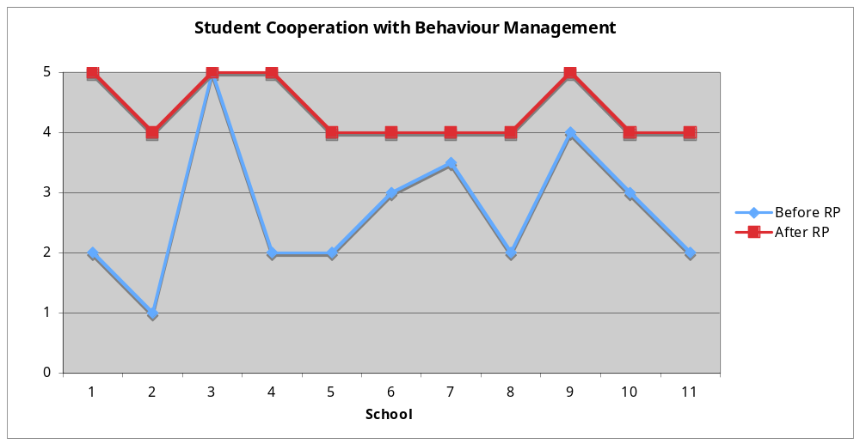

Figure 1

As indicated by the graph only two schools rated student co-operation with behaviour management processes to be high or very high prior to the introduction of restorative practices. Three rated this co-operation to be average while five rated it to be low and one very low.

After the introduction of restorative practices every school reported student cooperation with behaviour management processes to be high or very high, with seven being high and four being very high. This finding indicates a high success rate with student co-operation following implementation. When teachers witness such improved co-operation it is likely that they will feel commitment to and confidence in the processes.

The following comment by one of the schools reporting prior high co-operation indicated that they didn’t introduce restorative practices out of a need to manage student behaviour but that it was seen as a better way of doing things as it is more relational.

“We don’t have many significant behaviour issues but the difference is the response we get from students using restorative practices – they are more willing to share the problem – they are responding according to the delivery.”

This comment highlights the effectiveness of the pro-active nature of restorative approaches as a behaviour management tool.

Q16. Students’ sense of belonging to the school community prior to the introduction of restorative practices
Q17. Students’ sense of belonging to the school community currently
Q33. How effective restorative practices have been in improving the connectedness/sense of belonging students have with their school.

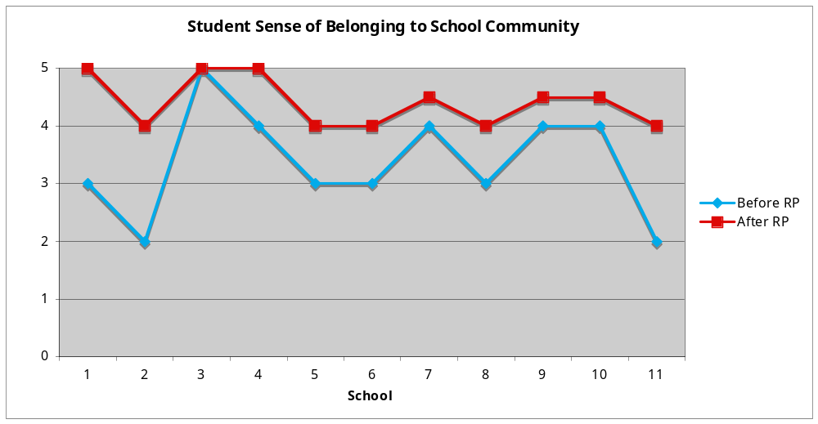
Figure 2

One school rated the students’ sense of belonging to the school prior to the introduction of restorative practices as very high and five rated it as high. Four schools rated this as average and two as low.

All schools reported this sense of belonging currently to be high or very high, with three rating this at very high, five at high and three as between high and very high.

Significantly nine schools believed that the students’ sense of connectedness/belonging to the school community had improved with the introduction of restorative practices to a high or very high level. Of the two schools who reported an average level of improvement one felt unable to decide on a single factor to account for this.

Q18. Indicate whether or not there has been positive change in the school climate since the use of restorative practices
Q19. Rate the extent of this change (Figure 3)

All schools experienced a positive change in the school climate since the introduction of restorative practices with only one school reporting this change below the middle range. Six schools rated the extent of this change at high or very high. This indicates a very positive outcome of the implementation. Some respondents speculated on reasons for this positive change with comments such as -

- “Kids like to have a chance to have a say”
- “Hearing the effect on the victim makes students more understanding of others
- “There has been a big change in terms of student recognition for the need to repair relationships.”

Q31. Effectiveness of restorative practices in improving peer relationships between students (Figure3)
Q32 Effectiveness of restorative practices in improving relationships between teachers and students (Figure 3)

Eight schools indicated that peer relationships had improved since the introduction of restorative practices to a high or very high level, and three schools reported this level to be at least in the middle range.

The rate of improvement of the teacher student relationship was found to be even higher than this with ten schools rating this improvement as high or very high. One school indicated that there had been a marked improvement in teacher student relationships but was unable to decide on a single contributing factor.

These findings indicate that improved relationships are an expected outcome of the use of restorative practices.

Q36. The impact of the use of restorative practices on staff well-being (Figure 3)
Q37. Relevant data, e.g. no of staff sick days, student absenteeism/truancy

Research from the UK has indicated that there had been a reduction in the number of staff sick days since the use of restorative practices in schools (See Appendix 2). Unfortunately none of the participating schools have data pertaining to this. (It is interesting, however, to refer to the results from Q38 in Section Three relating to the use of TRTs untrained in the use of restorative practices as they have relevance to staff well-being.
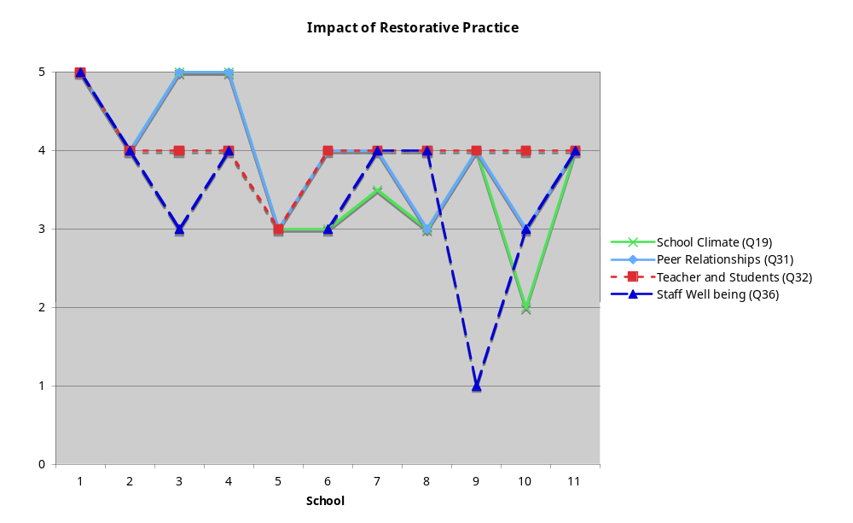

Figure 3

Section Three - Restorative Practice Methodology Implemented

Q20. Some consequences the school uses for discipline referrals, including harassment and bullying incidents?

This question was designed to get a picture of the full range of responses to discipline breaches both before and after the introduction of restorative practices. (The number in brackets indicates the number of schools using these responses.)

- Parent contact (8)
- Time out of class (9)
- Time out - yard play (4)
- Restricted play (2)
- Time out in office/with management staff (4)
- Time out with Aboriginal mentor (1)
- Suspension (10)
- Exclusion (4)
- Counsellor referral (1)
- External behaviour unit support (1)
- Think sheet (1)
- Accountability interview (1)
- Re enrolment interview (1)
- Social skills circle time (1)
- Letter of apology (1)
- Detention (2)
- Restorative conferences (11)
- Restorative chats (3)
- Circle time (2)

Restorative conferences, small large, formal and informal would by necessity include restorative chats yet these were not singled out for mention by as many schools as reported using these conferences. Similarly, parent contact must be used in the case of suspension and exclusion yet schools didn’t necessarily indicate this when they identified using suspensions and exclusions. A formal conference, for instance would include the signing of an agreement by students yet this was not singled out as a possible response.

Q23.Three consequences believed to be used most often before the introduction of restorative practices (no data).

The practices highlighted as being used most often by schools were -

- Exclusion
- Suspension
- Detention
- Time out
- Parent communication
- Discussions
- Counselling
- Loss of privileges/restricted play
- In school Behaviour Management Steps, e.g. Rethink 5 step plan

Five, possibly seven of these consequences, depending on delivery style, are punitive in nature and have the effect of isolating the student from the school community. A feature of these responses it that isolation limits opportunities for the restoration of relationships and disengages the offender from communication with others involved.

Q26. Since the introduction of restorative practices list three discipline referral practices believed to be used most often by staff (no data).
Q28. Rate the uptake of these consequences (no data available)

Practices used most often by the staff currently are –

- Small group conferencing
- Counselling
- Time out (various styles, e.g. rethink room/sheet
- Restricted play
- Restorative referral
- Restorative chats in classroom
- One on one restorative chats in yard
- Detention
- Group conferences
- Parent contact
- Small circle time

With the introduction of restorative practices there have been less punitive measures employed as consequences to inappropriate student behaviours and the focus is more on interaction and communication between all stakeholders. This allows opportunities for all involved to talk about what happened, how it affected people, to have a say in what happens next and to learn, develop and practice skills in peaceful negotiation.

Q22. Data for consequences used prior to the introduction of restorative practices
Q24. Data on consequences since the introduction of restorative practices

Only a small number of schools were able to supply data related to these questions.

One Government Primary School provided the following data on suspensions and behavioural referrals, indicating a large drop in the number of these since the introduction of restorative practices in 2006. It is interesting to note that in 2009 there had been an increase in suspensions, of some newly enrolled students who the respondent concluded had not yet learnt skills for conducting respectful relationships like other students at the school.

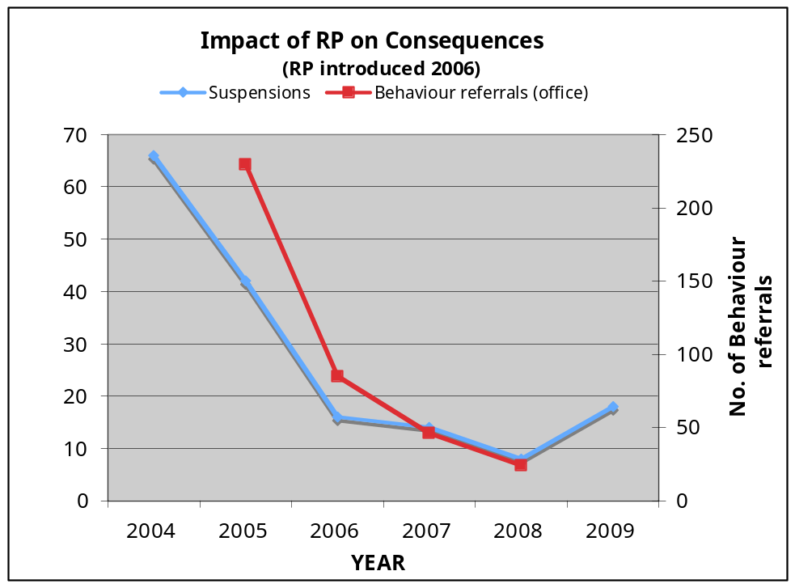

As the chart demonstrates there has been a large decrease in the number of incidents classroom teachers are referring to the office for the Counsellor or senior staff to follow up. The respondent believes that the use of restorative chats by teachers at the one to one level in the classroom has defused issues and built stronger relationships between teachers and students so that issues are discussed when they first arise and students feel heard. There is very high usage of small impromptu chats and small group conferences at the school. In mid year 2009 there were 19 active agreements resulting from large group conferences, none of which had been broken at the time of the interview, indicating student respect for them.

Another Government Primary School was able to supply data on bullying and harassment which they felt had been directly and positively impacted upon by the adoption of restorative practices. The steady decrease coincides with the use of restorative practices. The period of time covered by this is from the year of introduction of restorative practices and shows a significant drop in the number of identified bullies.

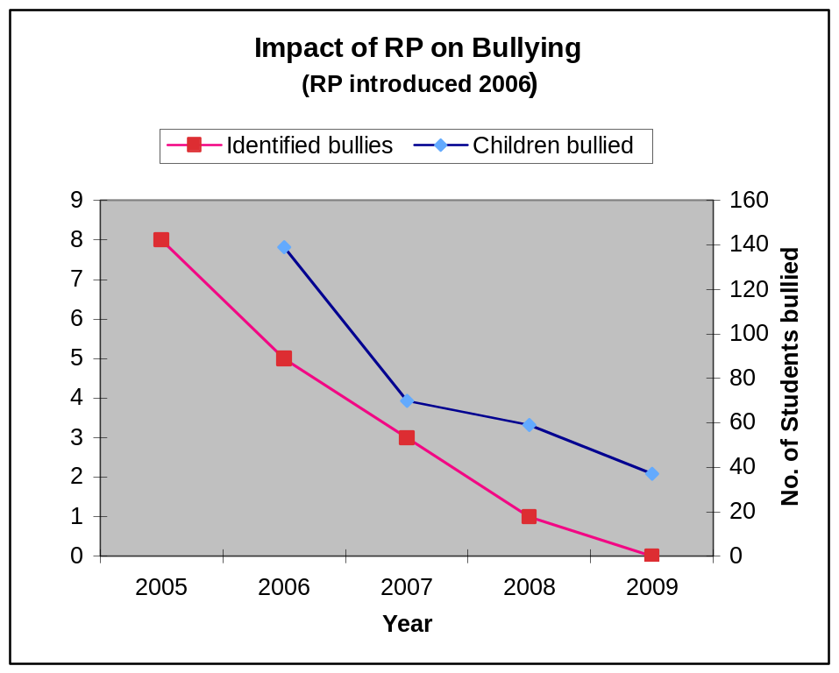

Q29. Skills used by students since the introduction of restorative practices.

Use of affective statements

Using circle principles informally
Use of peer mediation for yard incidents

Peaceful conflict resolution
Respectful peer relationships

Respectful large group discussion
Inclusive relationships

Appropriate classroom behaviour
Resolution of conflicts without input from external locust of control

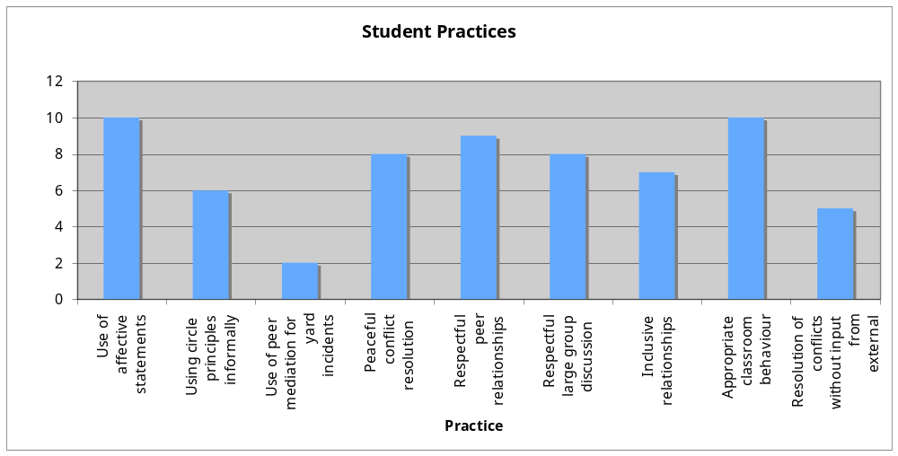
These findings indicate restorative approaches have helped students develop social skills which would enhance their resiliency and their success at school, both socially and academically due to an increased feeling of well-being. Ten schools reported the use of affective statements by students and the adoption of appropriate behaviour in the classroom. Eight schools reported students using peaceful conflict resolution methods, developing respectful peer relationships, developing inclusive relationships and the ability to participate respectfully in large group discussions.

Q30.Skills used by staff since the introduction of restorative practices.

Use of affective statements

Using circles
Peaceful conflict resolution

Respectful peer relationships

Respectful large group discussion

Inclusive relationships
Resolution of conflicts without input from external locust of control

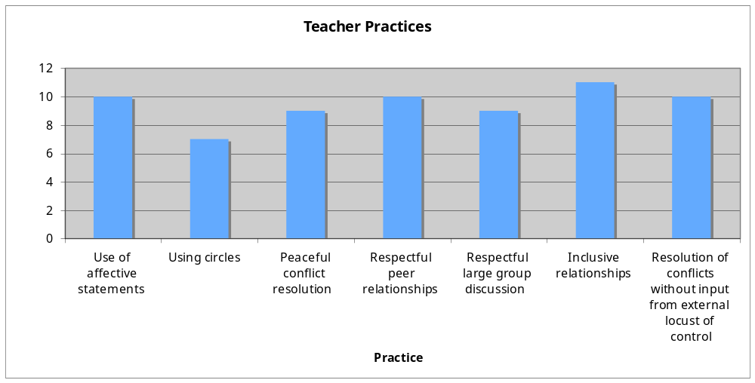
As the graph indicates, a very high number of respondents reported that the staff use a number of skills since the introduction of restorative practices. Six schools only, however, reported the use of ‘circles’ which might indicate that staff need professional development in this area or are as yet unsure of the application and benefit of this skill to their particular needs.

Q38. Indicate the level of effect TRTs (temporary relieving teachers) who are untrained in restorative practices have on the number of behaviour referrals

There was a strong indication that the effect of TRTs who are untrained in restorative practices on discipline referrals is significant. Seven schools reported untrained TRTs had a high or very high effect on discipline referrals. Three schools reported this effect at a very low level and cited the reason being that all their TRTs receive training in restorative approaches. Some respondents noted that on the days when TRTs are present their days are busier due to an increase in the number of discipline referrals. Respondents offered various comments in response to this question, for example -

- “Our students point out the restorative routines to the TRTs”
- “Incidents escalate – lots of incidents on the days we have TRTs”
- “All our TRTs are trained in restorative approaches” (x 3)
- “Our kids are very used to being asked to negotiate and if a TRT doesn’t do this, the kids just think – ‘well they’re not interested in us’ – and then play up.”
- “When TRTs yell the kids buck up – they are used to teachers listening to them.”
- “We try to have regular TRTs who know how we operate”

Section Four Moving Forward

Q39. Unanticipated benefits which have occurred from using restorative practices.

Schools reported the following unanticipated benefits from using restorative practices. Many of these were repeated by schools, some in slightly different wording but with the same sentiment.

- An increased sense of student belonging to the school
- A lack of Yr 6 and Yr 7 students involved in incidents needing a response – the feeling here was that “they get it” and ensure they don’t act as offenders and/or victimise others - this was cited by two schools
- Student develop more resiliency skills through being involved in chats and conferences
- Teachers feel supported when staff are using similar processes and they too are given the chance to express their perspective and be listened to
- There is an increase in student participation in behaviour management processes
- Students feel an increased control over what’s happening to them in the management of incidents.
- Didn’t anticipate the improvement would be so dramatic – improvement was noticed within 4 weeks of initial trial
- There has been an uptake of practices by people from outside the school, e.g. parents
- Staff now have a common language/vehicle by which to express their feelings
- There has been real parent affirmation of the processes used
- The focus on harm goes straight to the core of issues
- An ability to deal with problems arising from cyber issues have increased the emotional capacity of students
- The levels of trust between staff and students has increased
- Care group teachers are trusted more because students feel they can have their say and are listened to
- It (RJ practices) has given birth to an informal mentoring system developing for some students
- Parents are modelling principles to their students
- Students are learning the power of negotiation
- There is a greater understanding of healthy relationships
- A stronger home and school connection
- Talk between parents and teachers has been encouraged so that parents have a better chance of hearing the whole story
- Students don’t start things because they don’t want a conference
- Students show genuine remorse/sincerity
- Students are very open in serious discussions
- There is a genuine desire to do something about the hurt
- The conference process deals with relationship issues

Q40. Indicators which show restorative practices are working

- Improved attendance
- Improved yard and classroom behaviour
- Decrease in major incidents
- Harassment surveys show a dramatic drop each term
- Problems are being solved in the classroom with less immediate referrals to the behaviour management coordinator
- No referrals from the junior school
- Many fewer referrals overall
- Issues resolved by teachers in a relational way
- Of the 200 agreements documented in 2007 only 4 were breached by students
- Data on “red seat” and detentions indicates less incidents
- Teachers understanding that detention for boys with learning difficulties don’t work
- Less suspensions
- Less exclusions
- Negotiations with students are easier
- Students are requesting restorative chats because they judge them to be a fair process
- Some “hard cases” are accepting responsibility and are being honest so they can get to have a say
- Fewer referrals of older students
- Lack of recidivism
- Students understand the process
- Students openly encourage the follow up of agreements
- Increased student participation in discussions
- Decrease in the number of bullies and victims

Q41. Percentage of students for whom restorative practices have little or no effect
Q42. Suggestions for managing students for whom restorative practices have little or no effect

Eight schools indicated a 1 (very low) for this and the remaining four a 2 (low) suggesting that the number of students for whom restorative practices have little or no effect is very small. One school indicated just two students from a population of 250 for whom the practices did not work.

Suggestions for the management of these students

- Threat of suspension or other serious punitive consequences
- Individualised programs since it was often the result of language difficulties
- Individualised programs since it was often the result of the inability to empathise (special needs students such as those with Autism)
- Make timetable changes for the student to remove them from the problem environment
- Mentoring
- Increased counselling
- Build the relationship
- Naine Walker processes (see Appendix 4)
- Bring in outside neutrals
- Increase time spent with the individual student
- Be persistent – pointing out that they have forfeited their right to speak often convinces them to try the restorative process
- Suspending them but later inviting them to come back and take part in a restorative conference often “wins’ them over to the process
- Very young (reception) students who don’t yet understand the concepts may need immediate punitive consequences, e.g. limited play
- Get parents involved in intervention
- Use respected elders in intervention

Q43. Level of school’s commitment to retain the use of restorative practices

Q44. Level of school’s commitment to expand the use of restorative practices

Most schools were committed to retain and expand the use of restorative practices indicating a strong belief in the processes. Ten schools recorded their commitment to retain the use of restorative practices as high or very high, with eight of these being very high. The one school which recorded their commitment as low suggested this occurred recently because of a change of personnel. The commitment of eight schools to expand the use of restorative practices was either high or very high, with one school indicating that they actively seek grants to enable them to develop strategies in this area. Two schools considered they had only an average commitment to expansion, one because they felt that with still being in transition they needed to consolidate rather than expand and the other reported their current focus on a complementary program running parallel to restorative practices– Positive Behaviour for Learning (PBL). The one school that recorded the lowest commitment to expansion cited a change in personnel for the reason and suggested that they hoped that this was a temporary setback.

Q45. The case studies shared by the respondents are attached in Appendix 3.

Discussion

Five key interrelated outcomes highlighted the pro-active strengths of RJ approaches.

- respectful relationships
- student co-operation
- increased skills
- positive school climate
- increased sense of belonging to the school

An increase in student and teacher skills to respond to concerns and problems using restorative approaches lead to the development of the four other outcomes listed above. Healthy and respectful relationships between students and teachers developed because of an increased trust in teachers by students that they will be included in the resolution of problems. Through affective statements and conferences students tell their story, how they feel and what they think should happen. This engagement increased their skills of negotiation and resiliency and meant they are likely to cooperate with teachers in the future, leading an improved school climate and an increased sense of belonging and commitment to the school.

Students learnt to empathise with others, as they saw the effect of their behaviours on others and their tolerance increased, leading to a genuine desire to repair the harm. An improvement in classroom behaviour was attributed to strengthened relationships between teachers and students and an ability to develop respectful relationships. The improvement in relationships spreads to the greater school community as parents become involved in the resolution of the problem through involvement in conferences. Some parents used the approaches with their children at home, which strengthened the relationship between the school and the home.

An improvement in the school climate resulted from a decrease in the number of behavioural issues and a drop in punitive responses. A parallel increase in the skills of students and teachers to negotiate and build respectful relationships meant conflict was managed in a peaceful way. The high effectiveness of RJ occurred when schools embraced restorative approaches as a whole school approach, integrated into all aspects of operation, had a champion of the ‘cause’ and ensured staff had professional development in RJ.

Concluding remarks

Respondents were enthusiastic about the effectiveness of restorative practices at their schools, although the implementation was not without its challenges. A lack of time and money to ensure the continued maintenance and evaluation of the practices, and a perception by some, that only adversarial consequences deter students from inappropriate behaviours were highlighted. Additionally, due to the fluctuating nature of personnel it is a challenge to develop in staff a common and sound understanding of RJ approaches and skills.

There was an overwhelming commitment to retain the use of these practices. For a very small number of students restorative approaches do not work and it is suggested these students be managed through developing and strengthening relationships.

The Case Studies (Appendix 2) are a testament to the pro-active power of RJ practices to make a positive difference to students as they learnt to cope with the challenges of living respectfully with others and to teachers as they were empowered to turn around the school climate.

Judith Burnell

Appendix

- The questionnaire


Centre for RESTORATIVE JUSTICE

Offenders Aid & Rehabilitation Services of SA Inc.

Name of school: Date:

Interviewer: Judith Burnell

Introduction

As you are aware I am currently undertaking research for the Centre for Restorative Justice (CRJ) as part of a Field Placement for postgraduate studies in the Masters of Mediation and Conflict Resolution at the University of South Australia. The aim of this research is to ensure best practice is implemented in school communities.

Questionnaire information

The attached is a copy of the questionnaire which I will administer when we meet. It has been sent to you in advance of our meeting so that you are aware of the content, especially that relating to the availability of data. You should not fill this out in advance of our meeting. The actual interview session will take approximately 40 minutes with an option to extend if you are willing to discuss a case study. If you are prepared to share a case study you may have supporting documentation you wish to bring to our meeting.

What will happen to the survey results?

The results of this survey will be collated and used by the CRJ to analyse current approaches, and the effect of these practices on school communities, to inform best practices, to support current participants and to aid in the research and development of future initiatives.

Confidentiality

All information gathered will be confidential to the CRJ. You or your school will not be identified in any published findings unless you have agreed to this, subject to a specific request from the CRJ.

Thank you

Thank you for agreeing to be interviewed. The CRJ acknowledges the time you have put aside to participate and greatly appreciates your willingness to do so.

Name and signature of respondent

Name: ………………………………………… Signature: ………………………………………..

SECTION ONE

Q1. Which of the following options best describes the school? (Please tick)

Government co-educational primary [ ]
Government co-educational high [ ]
Government co-educational R to 12 [ ]
Independent co-educational primary [ ]
Independent co-educational high [ ]
Independent co-educational R to 12 [ ]
Independent single sex high [ ]
Other? Please describe.

…………………………………………………………………………………………………………….

Q2. What is the approximate population of the school?

…………………………………………………………………………………………………………….

Q3. What is your current position at the school?

…………………………………………………………………………………………………………….

Q4. On a five point scale where 1=low to 5=very high how would you rate your knowledge of restorative practices at the school? (Please circle)

1 2 3 4 5

Q5. On a five point scale where 1=low to 5=very high how would you rate your involvement in restorative practices at the school? (Please circle)

1 2 3 4 5

Q6. To your knowledge for how many years has the school been using restorative practices?

…………………………………………………………………………………………………………….

Q7. On a five point scale where 1 = low to 5 = very high how would you rate the school’s use of restorative practices as an integrated whole school approach to behaviour management? (Please circle)

1 2 3 4 5

Q8. Which of the following is closest to the percentage of staff members who use restorative approaches? (Please circle)

20% 40% 60% 80% 100%

Q9. Which of the following is closest to the number of hours of professional development on restorative practices staff have undertaken in the past 12 months? (Please circle)

2 4 6 8 10

Q10. Please describe the nature of this professional development.

……………………………… ………………………………… …………………………….

……………………………… ………………………………… …………………………….

Q11. Which of the following elements of restorative practices are regularly employed by staff/ or which the staff are encouraged by the school to use? (Please tick)

Affective statements (one on one chats) [ ]
Affective interactions (one on one - third party [ ]
Small impromptu conference/corridor chat [ ]
Large group (circle time) [ ]
Formal conferencing [ ]
Others? [ ]

Please describe others ………………. …………………… ……………………

Q12. Do you inform your parent body of changes to behaviour management policies? (Please circle)

Yes No

If yes please go to Q13, if no go to Q14

Q13. How do you inform your parent body of changes to behaviour management policies?

Please describe …………………. …………………….. …………………….

SECTION TWO

Q14. On a five point scale where 1=very low to 5=very high how would you rate student co-operation with behaviour management processes prior to the introduction of restorative practices? (Please circle)

1 2 3 4 5

Q15. On a five point scale where 1=very low to 5=very high how would you rate student co-operation with behaviour management processes currently?
(Please circle)

1 2 3 4 5

Q16. On a five point scale where 1=very low to 5=very high how would you rate the students’ sense of belonging to the school community prior to the introduction of restorative practices? (Please circle)

1 2 3 4 5

Q17. On a five point scale where 1=very low to 5=very high how would you rate the students’ sense of belonging to the school community currently? (Please circle)

1 2 3 4 5

Q18. Have you noticed a positive change in the school climate since the use of restorative practices? (Please circle)

Yes No

If yes please go to Q19, if no go to Q20

Q19. On a five point scale where 1=very low to 5=very high how would you rate the extent of this change?

1 2 3 4 5

Q20. What are some of the consequences the school uses for discipline referrals, including harassment and bullying incidents?

.............................. ……………………. …………………….

.............................. ……………………. …………………….

.............................. ……………………. …………………….

Q21. Before the introduction of restorative practices, name at least three consequences which data suggests were used most often. If you have the supporting data available please go to Q22. If not, go to Q23.

.............................. ……………………. …………………….

.............................. ……………………. …………………….

.............................. ……………………. …………………….

Q22. Please record the data for these three consequences collected prior to the introduction of restorative practices.
.............................. ……………………. …………………….

Data dated ____ ___ ___

Go to Q24

Q23. Before the introduction of restorative practices, name at least three consequences which you believe were used most often.

.............................. ……………………. …………………….

.............................. ……………………. …………………….

Q24. Please supply data you have regarding the uptake of these consequences since the introduction of restorative practices at the school.

If you do not have this data go to Q25

.............................. ……………………. …………………….

Data dated ____ ___ ___

Go to Q26

Q25. For each of the three consequences how would you rate the uptake of the consequences on a five point scale where 1=very low to 5=very high. (Please circle)

1. ………………………………… 1 2 3 4 5

2. ………………………………… 1 2 3 4 5

3. ………………………………… 1 2 3 4 5
Q26. Since the introduction of restorative practices list three discipline referral practices that are used most often by staff.

1. ………………………….. 2. …………………………… 3. …………………………..

If you have data to support the uptake of these go to Q27. If not, go to Q28

Q27. Please supply the data for each of the consequences named in Q26

1. ………………………….. 2. …………………………… 3. …………………………..

Data dated ____ ___ ___

Q28. For each of the three consequences in Q26 how would you rate the uptake of these consequences on a five point scale where 1=very low to 5=very high. (Please circle)

1. ………………………………… 1 2 3 4 5

2. ………………………………… 1 2 3 4 5

3. ………………………………… 1 2 3 4 5

SECTION THREE

Q29. From the following list of skills, indicate those which are being used by students since the introduction of restorative practices. (Please tick)

Use of affective statements [ ]
Using circle principles informally [ ]
Use of peer mediation for yard incidents [ ]
Peaceful conflict resolution [ ]
Respectful peer relationships [ ]
Respectful large group discussion [ ]
Inclusive relationships [ ]
Appropriate classroom behaviour [ ]
Resolution of conflicts without input from external locust of control [ ]

Q30. From the following list of skills, indicate those which are being used by staff since the introduction of restorative practices. (Please tick)

Use of affective statements [ ]
Using circles [ ]
Peaceful conflict resolution [ ]
Respectful peer relationships [ ]
Respectful large group discussion [ ]
Inclusive relationships [ ]
Resolution of conflicts without input from external locust of control [ ]

Q31. On a five point scale where 1=very low to 5=very high indicate how effective restorative practices have been in improving peer relationships between students. (Please circle)

1 2 3 4 5

Q32 On a five point scale where 1=very low to 5=very high indicate how effective restorative practices have been in improving relationships between teachers and students. (Please circle)

1 2 3 4 5

Q33. On a five point scale where 1=very low to 5=very high indicate how effective restorative practices have been in improving the connectedness/sense of belonging students have with their school. (Please circle)

1 2 3 4 5

Q34. On a five point scale where 1=very low to 5=very high indicate the level of staff commitment to teaching restoratively. (Please circle)

1 2 3 4 5

Q35. On a five point scale where 1=very low to 5=very high indicate the level of teacher cooperation with using restorative practices. (Please circle)

1 2 3 4 5

Q36. On a five point scale where 1=very low to 5=very high indicate the level of impact of the use of restorative practices on staff well-being. (Please circle)

1 2 3 4 5

Q37. Please supply any data relevant to Q34, e.g. no of staff sick days, student absenteeism/truancy.

……………………………………………………………………………………………………………..

Data dated ____ ___ ___

Q38. On a five point scale where 1=very low to 5=very high indicate the level of effect TRTs who are untrained in restorative practices have on the number of behaviour referrals. (Please circle)

1 2 3 4 5

SECTION FOUR

Q39. List any unanticipated benefits which have occurred from using restorative practices.

……………………………… ………………………………… …………………………….

Q40. List any indicators you have that restorative practices are working.

……………………………… ………………………………… …………………………….

Q41. On a five point scale where 1=very low to 5=very high indicate the percentage of students for whom restorative practices have little or no effect. (Please circle)

1 2 3 4 5

Q42. List any suggestions which might assist in the management of students for whom restorative practices have little or no effect.

……………………………… ………………………………… …………………………….
Q43. On a five point scale where 1=very low to 5=very high indicate the level of your school’s commitment to retain the use of restorative practices. (Please circle)

1 2 3 4 5

Q44. On a five point scale where 1=very low to 5=very high indicate the level of your school’s commitment to expand the use of restorative practices. (Please circle)

1 2 3 4 5

Q45. Outline of a case study (or share anecdotal evidence) illustrating the benefits of restorative approaches. (Please attach any relevant documentation.)

- Case studies

CASE STUDY 1
An incidence of physical violence in the yard
___________________________________________________
A Year 5 boy, George, punched Warwick, a Year 6 boy, and Warwick received a blackened eye and a chipped tooth. The school decided to hold a restorative conference with the boys and their care givers in response to the incident. It took a lot of work to get George to agree to attend because he felt he had good cause to punch Warwick. The previous day when George was on time-out from yard play and sitting on the time-out seat Warwick threw stones at him, however, eventually George agreed to attend.
Warwick’s grandmother attended the conference and was visibly very cross about the injuries to her grandchild. When she heard George tell his story about how Warwick had thrown stones at him, however, she changed her attitude and spent some time talking to Warwick about such disrespectful behaviour towards others. George had been able to tell his story and when he saw Warwick’s grandmother who had previously been negative with him change her attitude he felt relieved. He changed his approach at the conference and was prepared to participate effectively in the conference because he felt he had been given a voice.
The next year George was to be escalated a year and would be in the 6/7 class with Warwick. When they had to choose partners for transition activities George chose Warwick to help him. The resolution had been effective to the point of them sharing a comfortable relationship. There has not been another negative incident between them for around twelve months.
(there was a cultural difference between the two boys but this was not identified as a cause of the fight).
Outcomes
_____________________________________________________________________
• A new healthy and respectful friendship
• Care givers awareness of the whole story
• An appreciation of Restorative Practices for caregivers
• Open communication between the school and caregivers

CASE STUDY 2
Concerning a disengaged and disruptive student
___________________________________________________
Joe, at aged 10, was from an extremely disadvantaged background. His father was in prison and he was moved around from family member to family member, both interstate and to rural areas with SA. He presented as angry, rude and disruptive when he finally returned to the school community. Joe’s teacher and other staff had approached the Student Counsellor at a loss to know what to do to improve the situation for him and for others with whom he interacted. The Student Counsellor had quite coincidentally heard about Restorative Practices and asked the teacher if they would be prepared to trial such an approach with Joe.
The Counsellor undertook training in Restorative practices and did lots of reading around the restorative approach after which he worked with the teacher concerned on possible strategies and practices to adopt when working with Joe in the classroom when incidents arose. Within four weeks the teacher noticed Joe to be “a different boy”. Even though he was still being disruptive at this stage he was “talking to” his teacher.
Communication had been established. Within a term he was attending all classes and even though there was still some anger present he was using strategies to “cool down”.
The following year, by the end of the first term Joe was behaving like the other students. Now in Year 7, Joe has not been referred to the office for two years and is a respected leader in the school community.
The School Counsellor remarked that restorative approaches had turned his life around.
Outcomes
____________________________________________________________________
• A functional and respectful relationship between student and teacher
• Healthier peer relationships
• Improved attendance
• A sense of connectedness to the school

CASE STUDY 3
An incidence of harassment in the community
_____________________________________________________________

This case study involved a Year 9 and Year 10 boy and their parents. The Year 9 student ‘egged’ the Year 10 boy’s house because of ongoing tensions between the two at school, at the church their families attended and at youth group.
The parents of the Year 10 boy were upset by the incident and decided they would like to deal with it using a restorative approach. They invited the Year 9 boy and his parents to participate in a restorative conference about the matter. Each boy was able to give his version of what happened and the parents of the Year 10 boy were able to explain how the ’egging’ impacted on their family.
The parents gave feedback to the school indicating the success of the process. They explained that because they felt there had been good outcomes and positive reports from their son when he had been involved in restorative interventions at the school they wanted to use the process in the community and heal the relationship between the two boys and with the other family.

Outcomes
____________________________________________________________________
• A functional and respectful relationship between student and teacher
• Healthier peer relationships
• Improved attendance
• A sense of connectedness to the school
• A level of academic engagement
• Social skills development

CASE STUDY 4
An incidence of ongoing harassment
_________________________________________________________

A group of Year 2 boys were targeting, and picking on another Year 2 boy, Tim, who had a disability and was unable to express himself verbally very well. Unbeknown to the teachers they were consistently making him feel very unhappy about himself and humiliating him in the eyes of the other students. Tim’s parents contacted the school when he became reluctant to go to school. They explained that they and noticed he often mentioned by name certain other students.
After talking to Tim the school decided to run a Restorative Conference with the boys he had named and himself. The facilitator found that the questions asked of the boys at the conference really unearthed the way in which the group of boys had been victimising Tim. For example, they had been hiding his things when he wasn’t watching them. Tim himself was empowered by the questioning to express himself in a way that the boys understood how sad he was being made by their behaviours. There was acknowledgement that the behaviour was wrong and should stop.
An agreement was discussed and made about what the perpetrators would have to do if they did such hurtful things again. Tim has been happy to come to school since the restorative conference and has not reported being targeted by the group since the conference.

Outcomes
______________________________________________________________________
• A level of academic engagement
• Social skills development
• A greater sense of well being
• Increased tolerance of differences

CASE STUDY 5
An incidence of dysfunctional relationships
_____________________________________________________________
Their teacher noticed that a group of girls in upper primary were very unhappy with each other and the way in which the group was interacting. They reported a lot of ‘niggling’ going on between them in the group which was damaging their self esteem but they still wanted to be friends. The school decided to take a restorative approach to deal with the negative relationships.
The facilitator, not the classroom teacher, began with one to one interviews with each of the girls and following this led a group circle session. There was some initial discussion about why they were there and then the girls were asked to go away and write negative things about relationships. The girls came back to the group and the facilitator shared with them the positives they had identified and the girls identified and discussed the positive things that were happening between them in the group. After that they talked briefly about the negatives from the list and identified those that concerned them most. Even though the facilitator deliberately didn’t dwell on the negatives there were some very powerful messages expressed by the girls about the extent of the effects of the negative behaviours on their well being.
From the meeting that day they moved forward as a group. They had several more meetings and developed goals for their interactions. When the facilitator sought feedback some time after these meetings from the classroom teacher it was reported that “the girls are getting on just fine”.
The facilitator concluded that the power of the restorative conference had been to open up the insidious things that were happening and provide a tool for dealing with them.
Outcomes
_____________________________________________________________________
• Healthier peer relationships
• Reparation of harms
• Increased empathy
• Increased wellbeing
• Peaceful conflict resolution
• Social skills development

CASE STUDY 6
An incidence of ongoing harassment
___________________________________________________________
A staff member received a phone call from the mother of Simon, a Year 5 student. She was very forthright and complained that a group of girls was harassing her son every morning and she demanded that something be done about it. She said that every morning when she dropped Simon off at school the girls would be waiting for him to arrive and would taunt him with names like “stinky”.
The staff member spoke to Simon who verified that his happened every morning and added that the girls would chase him around the yard calling him names until the bell rang every morning. He asked Simon if he could think of a reason why they did this but Simon was unable to come up with anything.
The staff member spoke to the group of girls involved who admitted they were doing this. When asked if there was any reason for this they explained that Simon was putting his finger in his nose, twirling it around and chasing them in a effort to touch them. “We think it’s gross!” was their conclusion.
The staff member got all the parties together and ran a restorative process with them. Simon said he wanted the name calling to stop. The girls agreed that they would stop if he stopped doing the “gross “ things he was doing. When asked by the staff member if he was doing “gross” things he agreed that he was and that he would stop. All parties kept to their word for the whole year.
Simon has experienced some other difficulties and there have been other issues the staff member has had to work through with him. He has found, however, that this has been made easier because he has been able to refer to the fact that the boy was able to keep to his word previously and could appeal for him to do the same in the current instance. The boy would agree that he would try. This has been an unexpected benefit of using restorative practices. For the staff member it is an indication of the power of the restorative process to change the culture of dealing with such conflict. Children understand that they can hold the key to the solutions that have traditionally rested with adults.
Outcomes
____________________________________________________________________
• Open communication between student and teacher
• Healthier peer relationships
• Social skills development
• Development of resiliency
• More effective communication between school and home

CASE STUDY 7
An incidence of ongoing harassment
____________________________________________________________
Three Year 4 girls, Marcia, Emma and Michelle, aged either 8 or 9, and their mothers were involved in this case.
There were a lot of relational issues between the three girls. Marcia was using a lot of covert verbal harassment against the other two, while Emma was tended to interact in an annoying physical way. Michelle wanted to be friends with both and exhibited manipulative behaviours towards them to achieve this. It was a difficult relationship with many ups and downs and it developed to a point where it was affecting others and the girls were bringing in bystanders. It was also apparent to the Counsellor and parents that there was a problem as all three girls were reluctant to come to school.
The Counsellor invited the girls and their care givers to participate in a Restorative Conference. The parents and three mothers all had different attitudes to being asked to participate. One didn’t want to be involved and thought the girls should sort it out themselves. Another was very defensive about any possible fault on her daughter’s behalf. The third had no idea as to how this could help.
The conference was very effective in spite of the parents being defensive at first. East of the girls was honest about their behaviour and the parents were able to hear each story in a no blame context. The Counsellor sensed that as the conference progressed an awareness was raised in the girls and their parents so that they were all able to suggest appropriate consequences if the negative behaviours happened again. The girls all signed an agreement which outlined very specific behaviour for them to comply with.
The conference was followed by closer monitoring of the girls by the Counsellor. At first this comprised of checks every few days and then weekly for a few weeks. Four months after the conference there has not needed to be any intervention in the relationship.
Outcomes
_________________________________________________________________
• A healthy and respectful relationship between a relationship group
• Social skills development
• Increased attendance
• Heightened awareness of restorative practices in parents
• Collaborative decision making between the school and parents

CASE STUDY 8
An incidence of intercultural harassment
_____________________________________________________________
A group of Aboriginal boys ranging in the age from 5 or 6 to 10 or 12 were reported to be harassing the Vietnamese grandfather of one of the younger students. Repeated harassment , in the form of name calling with strong sexual innuendo, was occurring when the grandfather collected his grandchild from school. This behaviour had been going on for a couple of months outside of the school grounds. In frustration the grandfather threatened the students and du to this the school’s attention became drawn to the situation. Some investigation of this threat was conducted and it was agreed to hold a restorative conference of all stakeholders.
16 people comprising staff, students and parents attended the conference, enacted by the Principal. The conference was facilitated by the Centre for Restorative Justice. A lot of groundwork was undertaken to ensure that all participants knew what to expect. A very positive outcome resulted—an apology was made to the grandfather and it was accepted. Those involved recognised that the boys would have greater understanding by knowing more about the Vietnamese culture and in fact the boys suggested the grandfather be asked to participate by coming into the school and sharing aspects of his culture. These culture sharing sessions had an indirect but significant part in leading to the introduction of Multicultural Nights at the school which eventually grew to include Aboriginal parents.
The facilitator concluded that the power of the restorative conference had been to open up the insidious things that were happening and provide a tool for dealing with them.

Outcomes
___________________________________________________________________
• Increased multicultural understanding
• Increased empathy
• Heightened parent awareness of restorative practices
• Increased communication between the school and home
• Conflict resolution through peaceful means

CASE STUDY 9
An incidence of intercultural harassment
_______________________________________________________________
It was near the end of Year 9 that a friendship group of girls began to splinter. There were a lot of nasty exchanges happening via a variety of mediums including phones, social networking sites and in the school setting through such things as hostile stares. One faction came to the Deputy seeking advice, concerned and quite scared by the escalation of the conflict. The Deputy interviewed the second the second group ad decided to facilitate a group, “no blame” restorative conference involving all the girls.
At the conference each group talked about their feelings about what was happening and the effect of the different behaviours on them. They listened to each other and agreed that they weren’t enjoying what was happening. They got to the stage where they were able to discuss what had triggered the conflict. They built an agreement of appropriate behaviours through there discussion. Since the conference they have been able to stick to agreements and interact peacefully. The Deputy feels that a conflict situation was significantly deescalated by the conference because, by listening to each other, harms were able to be repaired.
Perhaps the most affirming aspect of this case is that when the Deputy asked what the girls would do if the conflicted reignited they said they would come back and talk to him. He felt they recognised the power of the process as a non judgemental mechanism for resolving conflict and the benefits the sharing of each other’s feelings and needs can bring.
The final observation of the Deputy was that a punitive approach would have increased tension and hostility in the already fractured friendship group.

Outcomes
______________________________________________________________________
• Healthier peer relationships
• Reparation of harms
• Increased empathy
• Social skills development

CASE STUDY 10
A difficult teacher/student relationship
______________________________________________________________
A difficult relationship existed between a 9 year old, Year 4 boy, and his teacher. Jack was being an absolute ‘pain’ in class and be rarely behaved appropriately. There was little productive communication between Jack and his teacher. The teacher had exhausted many avenues for addressing the behaviour including parent contact but the situation did not improve.
The teacher approached her line manager who suggested a restorative conference be conducted with Jack, the teacher and herself. At first Jack was quite unresponsive but eventually through the process he opened up that he was angry at the teacher and didn’t trust her due to how past issues between them and other students and the teacher had been dealt with. This revelation was handled using a no blame approach and each party had a chance to talk and be heard. Both Jack and the teacher were encouraged to share their perspectives in detail.
An agreement between the teacher and Jack was developed in partnership and signed at the meeting. Jack suggested a reward system as part of the agreement and this system was in place for a number of months until it was no longer needed. The teacher reported a real improvement in behaviour and the emergence of a more trusting relationship between Jack and teacher. The boy’s parents were not at the conference but attended a subsequent meeting at which the conference, the agreement and follow up plan was outlined.
The teacher and her line manager believed it was finally hearing about the impact of Jack’s behaviours on the teacher which opened his eyes during the conference and encouraged him to open up and explain his point of view. The teacher, likewise, was able to understand the reasons behind his behaviour.
Outcomes
_____________________________________________________________________
• Reparation of harms
• Reestablishment of teacher/student relationship
• Increased empathy
• Social skills development
• Increased learning for peers in class due to less disruptions
• Enriched communication between teacher and home

- UK data re staff absenteeism/well-being

Endeavour Discipline Data Spring 2007 – July 2008 reports 62.5% fewer days staff absence (saving over 60,000 pounds in 8 months) cited in Mirsky L, 2009, ‘Hull, UK: Toward a Restorative City’, Restorative Practices E Forum, January 2009, pp. 1-2.

- Nairn Walker reference

Information regarding Social Solutions; educating for a positive now and Nairn Walker can be found at www.socialsolutions.com.au

